Microsoft Office Add-In for Mac Install Instructions

**Keep these instructions open through install process. The install will not work unless instructions are followed EXACTLY as described**

1. **Download the add in manifest file (download button in top right corner, save not open)**

<https://drive.google.com/file/d/0B1SYDWsAGxnTaXNVSmxVY1VwVUE/view?usp=sharing>

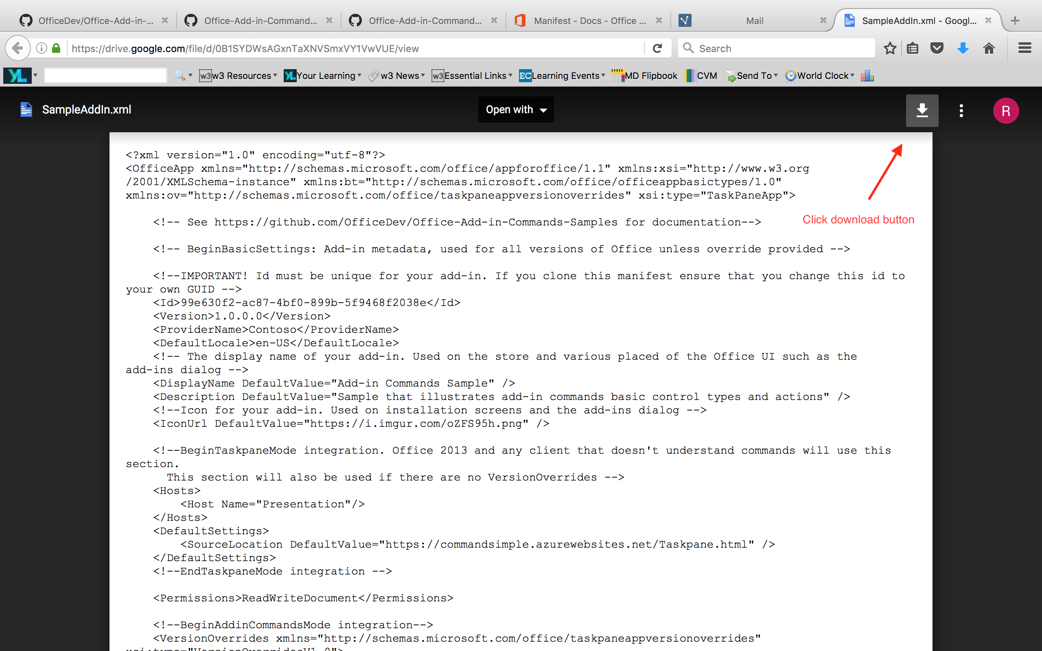

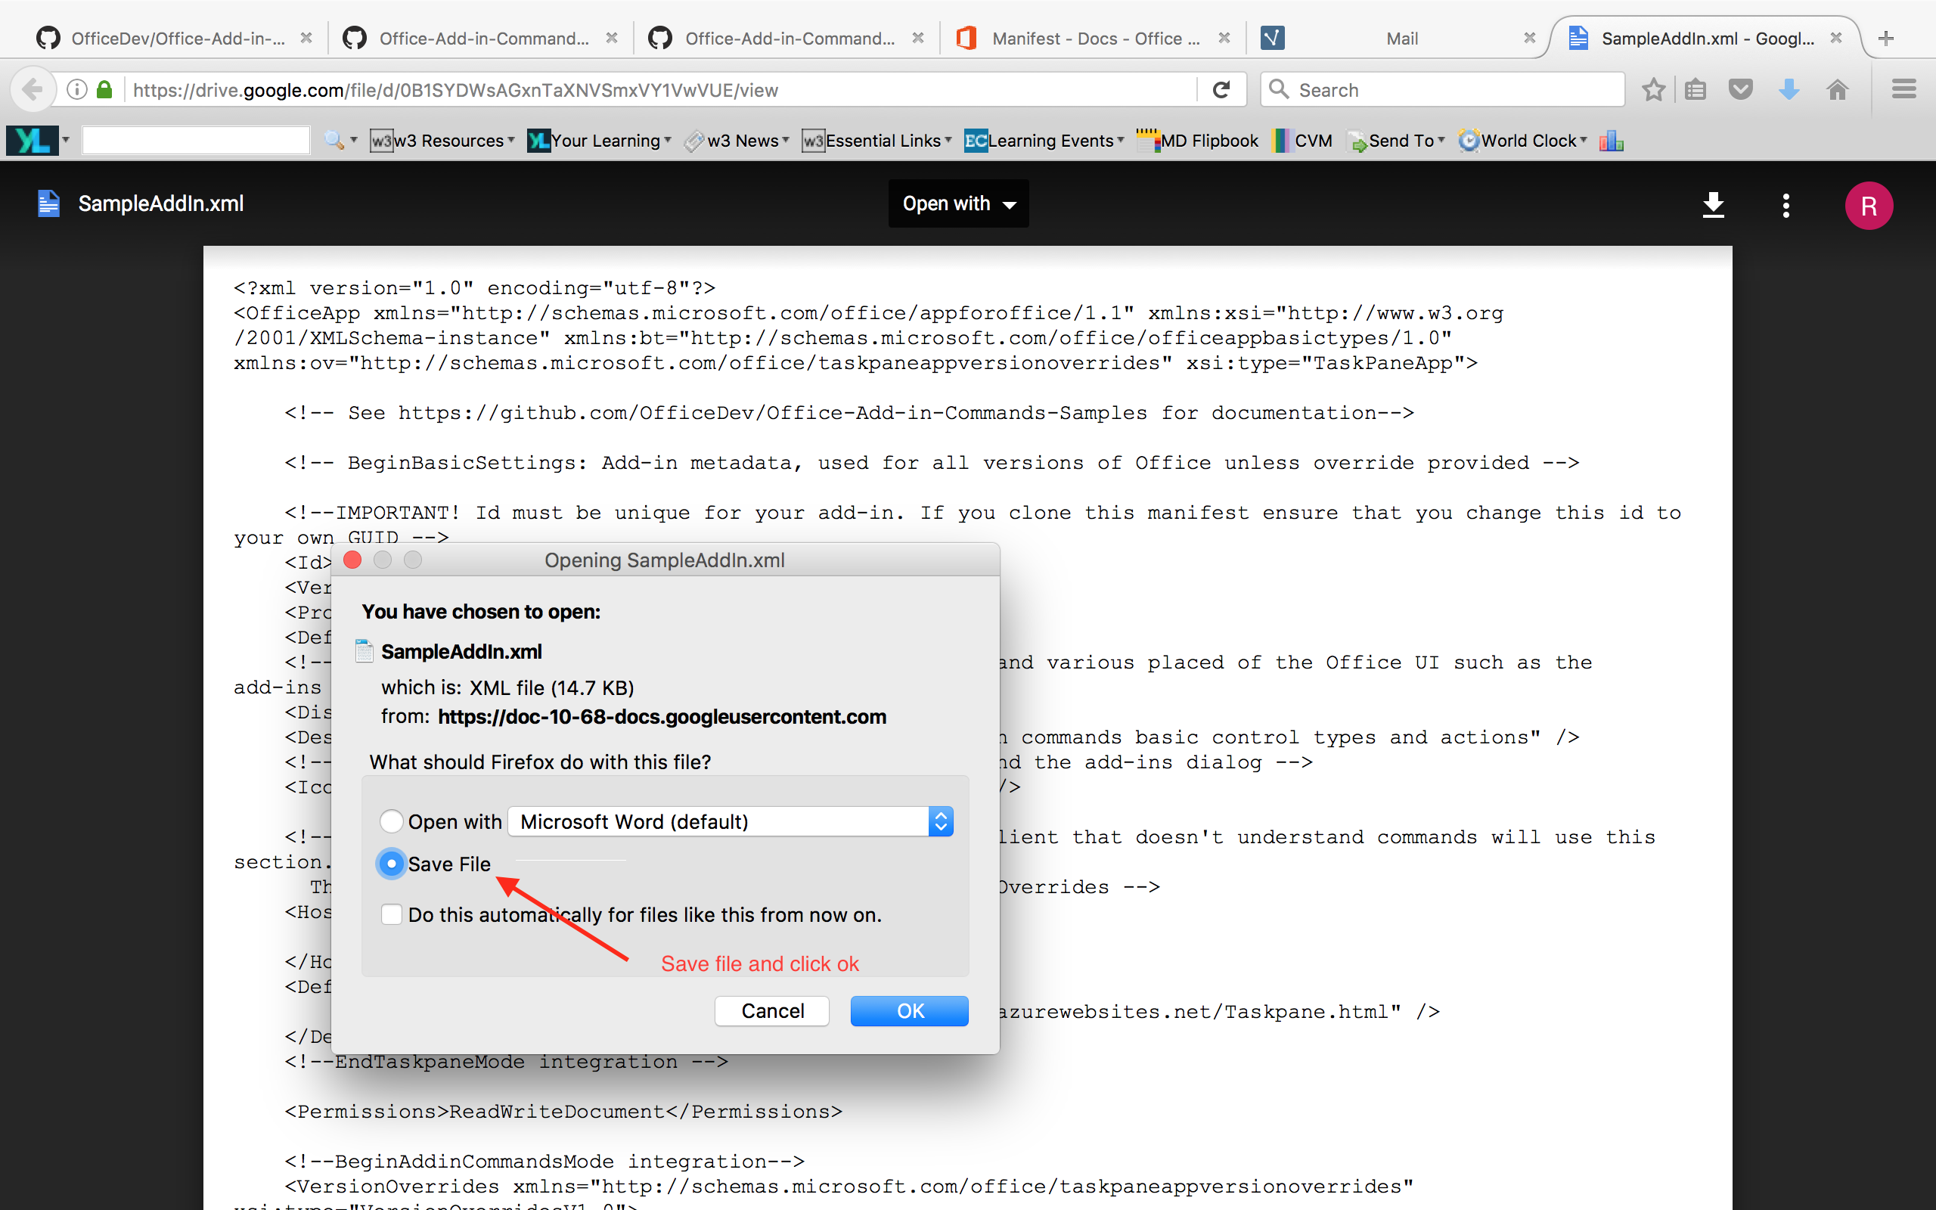

1. **Use [Cmd+Space > “terminal” > return] to open a new terminal window**

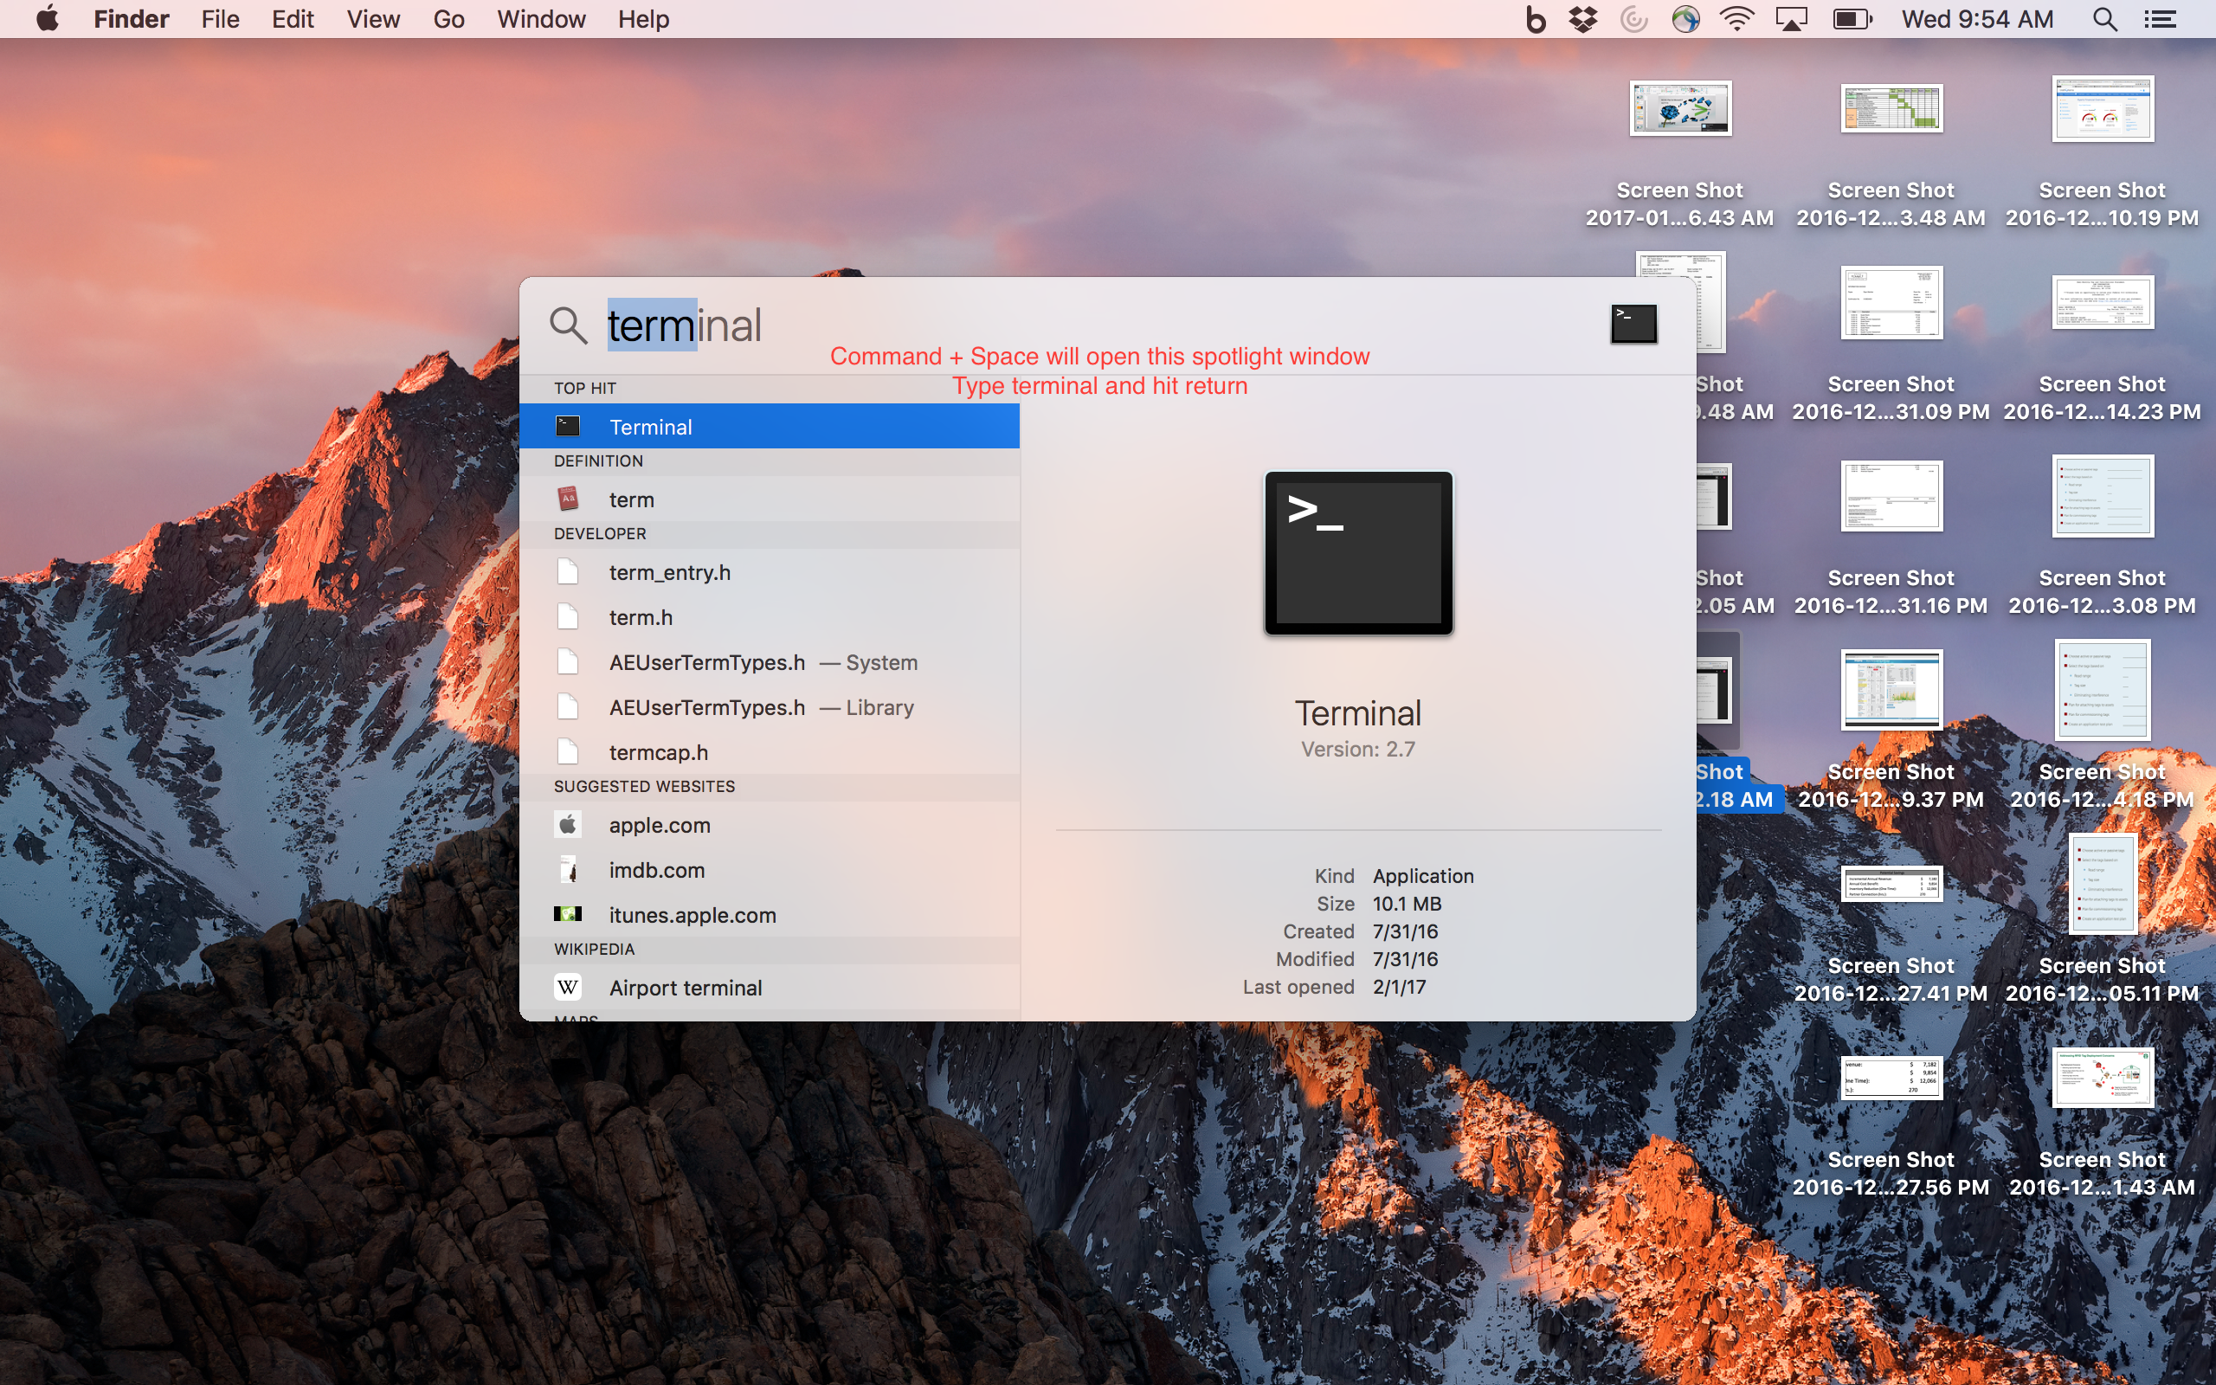

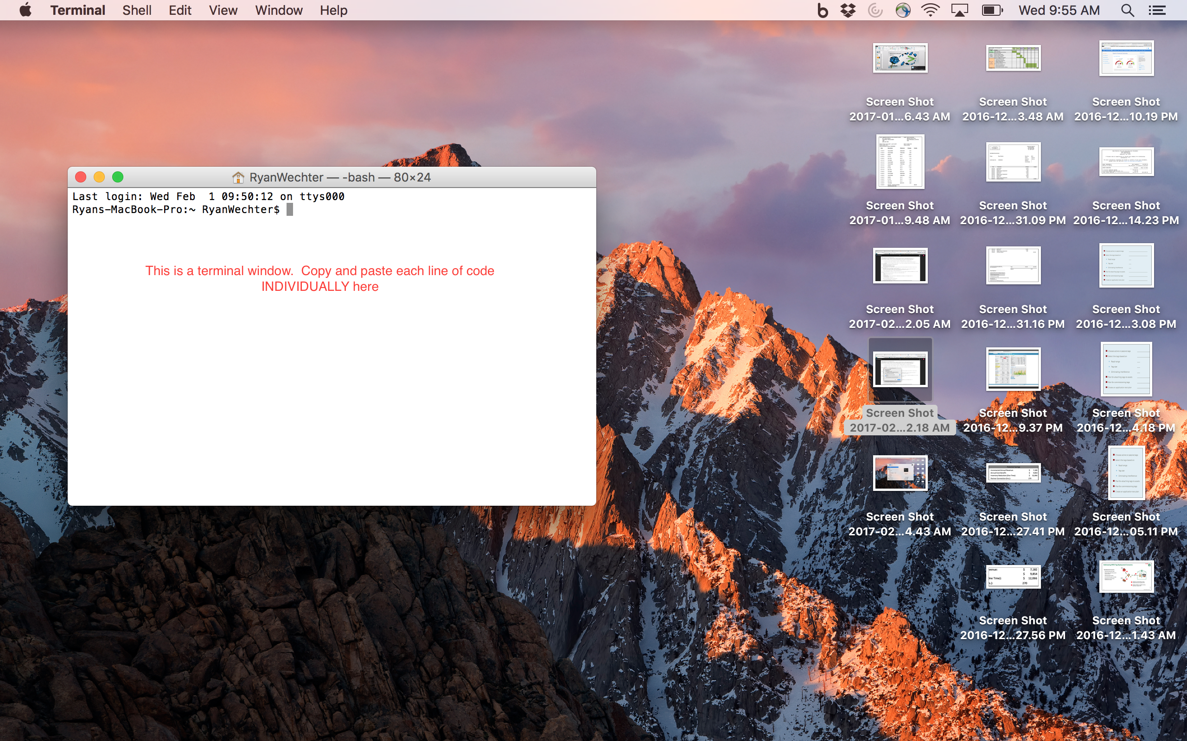

1. Copy and paste the following 2 lines of code into the open terminal window and hit return

mkdir ./Library/Containers/com.microsoft.Powerpoint/Data/Documents/wef

cp ./Downloads/SampleAddIn.xml ./Library/Containers/com.microsoft.Powerpoint/Data/Documents/wef/

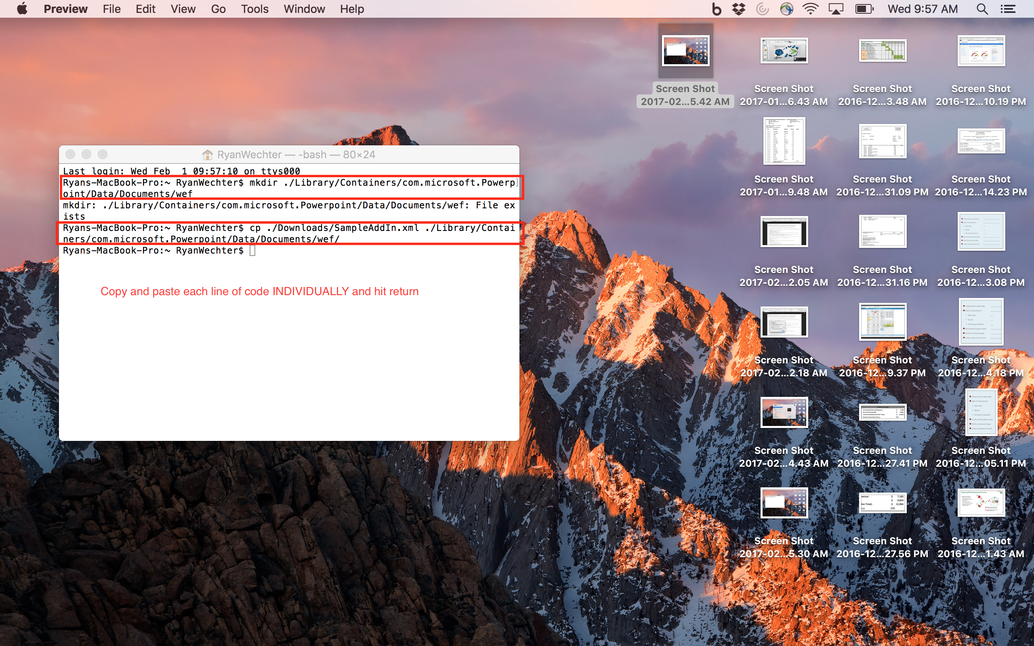

1. **Access Office Insider Fast (developers preview)**

Open Microsoft PowerPoint > Pull down ‘Help’ menu (top of screen) > Click ‘Check for Updates’ > Check ‘Join the Office Insider Program’ > Select ‘Office Insider Fast’ from drop down menu > Accept terms and conditions > Check for Updates > Update Microsoft Office

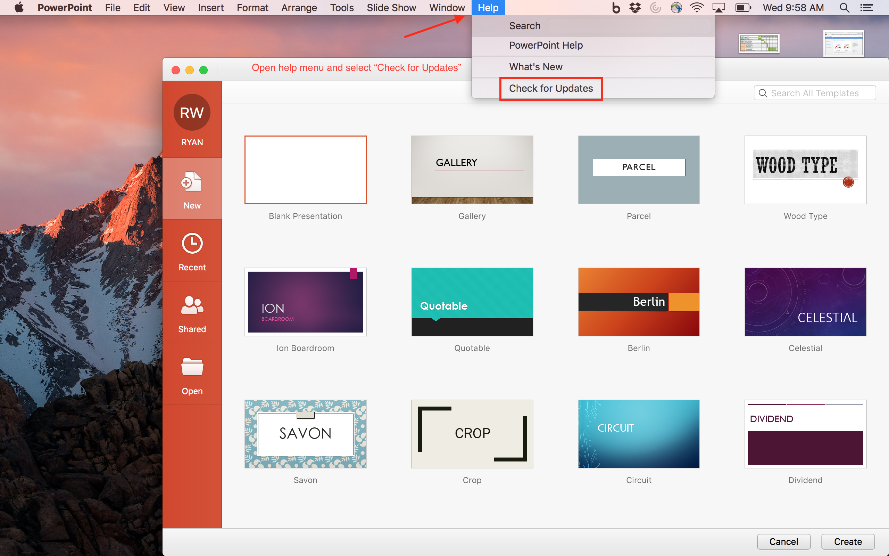

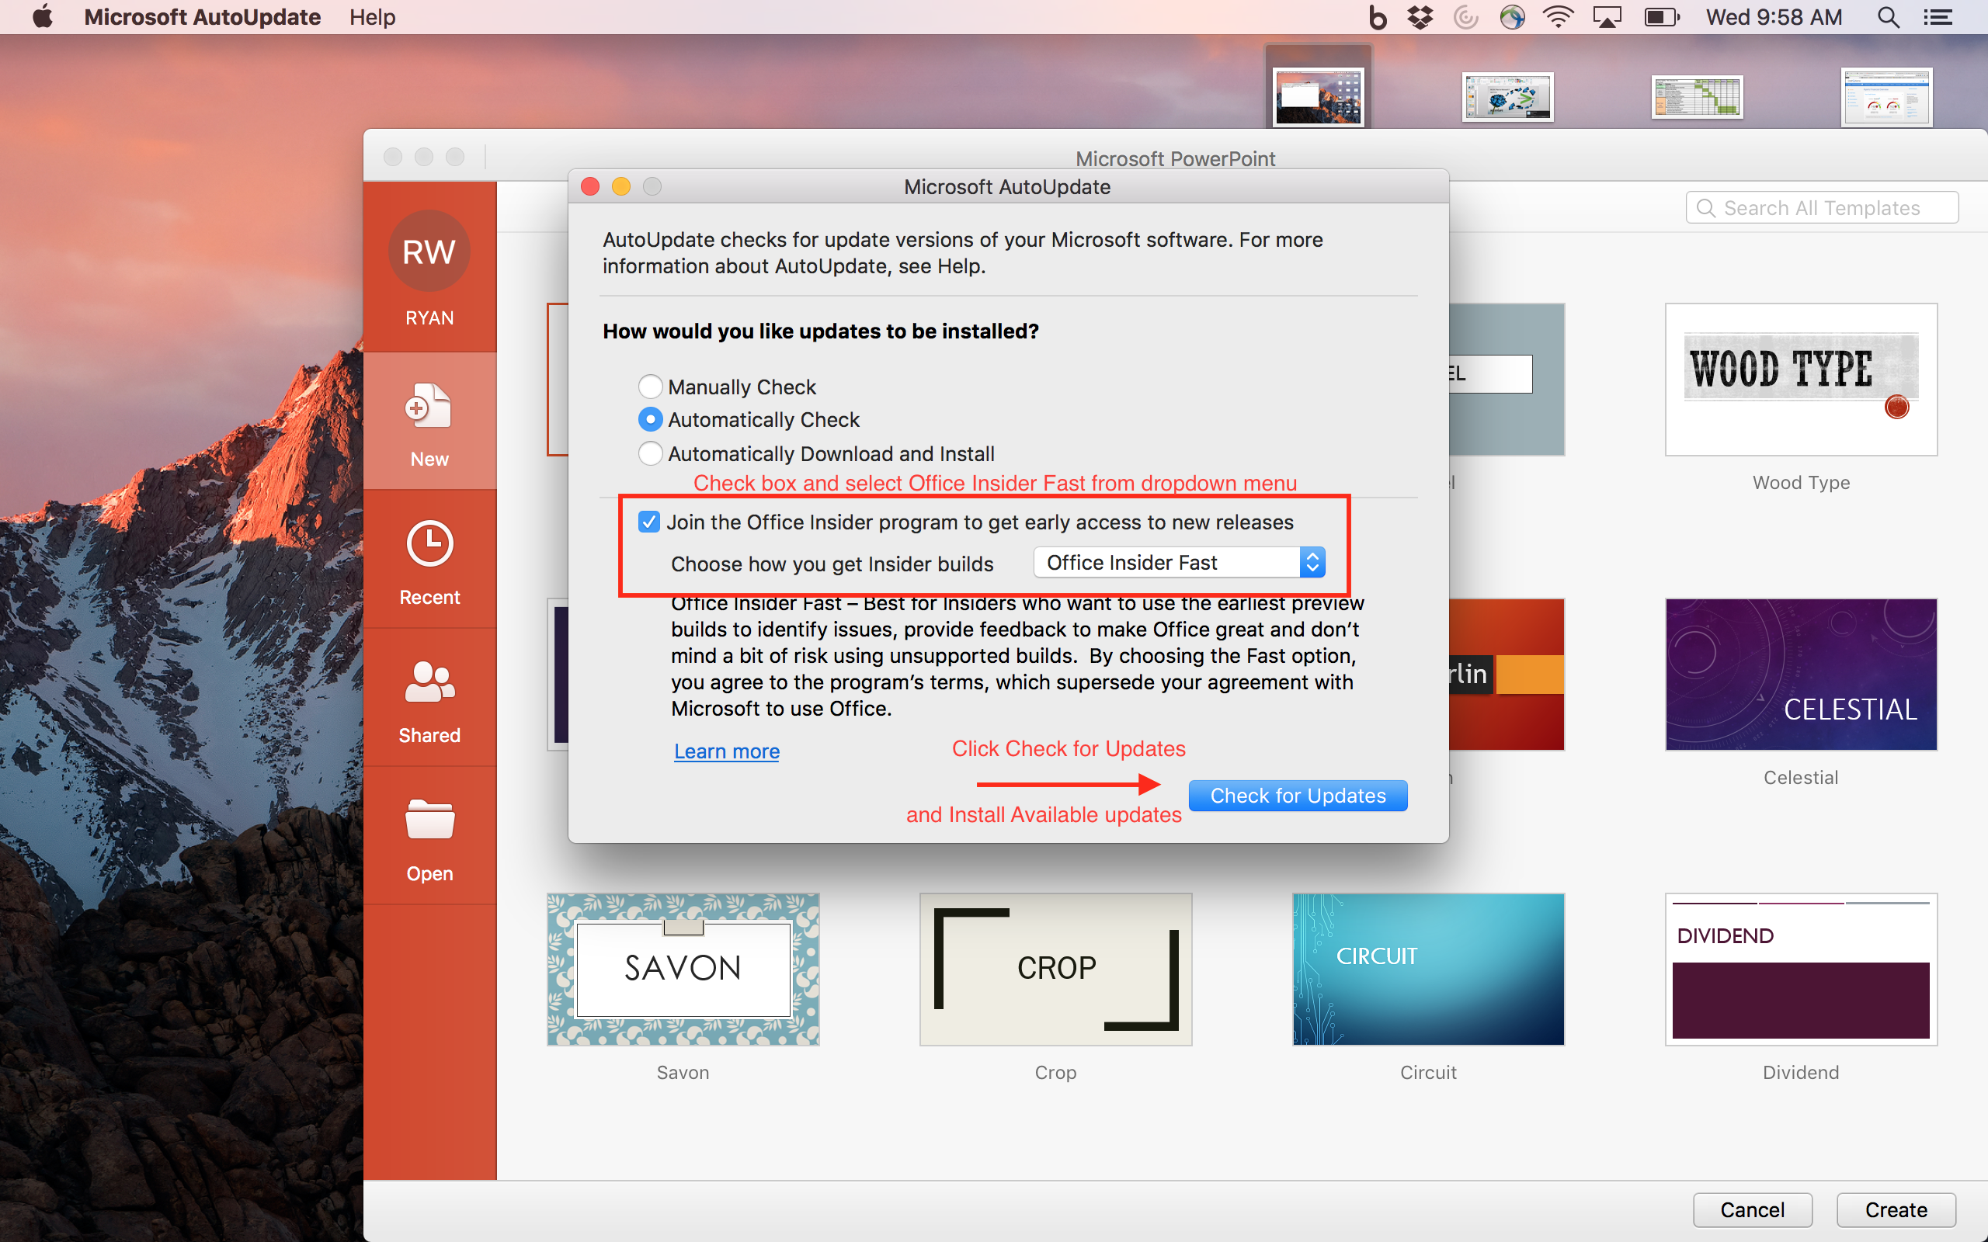

1. **Use Cmd+Space > “terminal” > return to open new terminal window**



1. Copy and paste the following line of code into the open terminal window and hit return

defaults write com.microsoft.Powerpoint EnableAddinCommandsDeveloperPreview 'YES'

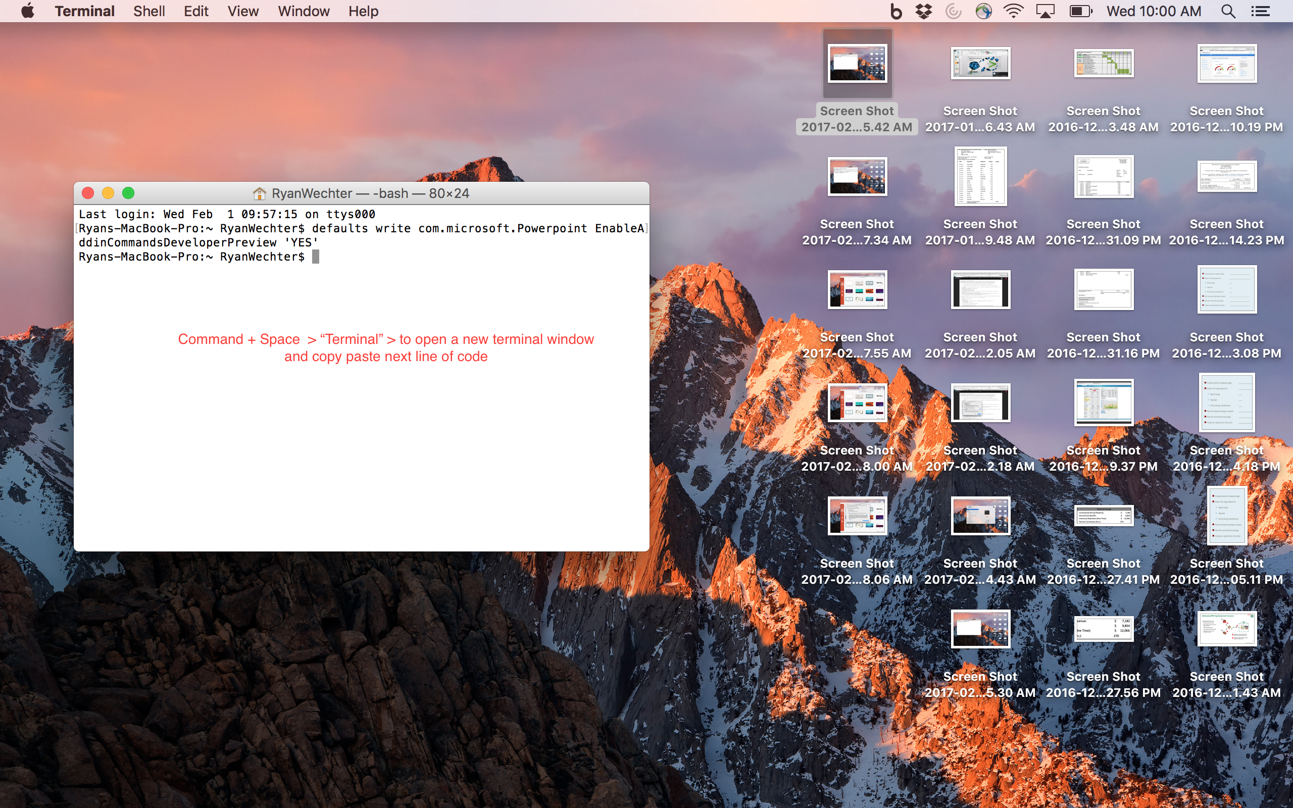

1. **Open PowerPoint and Load Add-In**

